R8 - Habits of mind and expansive dispositions

‘Habits of mind’ (HoM) as an approach to teaching and learning is the specific creation of Art Costa and Bena Kallick1 who suggest that there are sixteen habits of mind which define what humans do when they behave intelligently.

Costa and Kallick’s Habits of Mind
1. Persisting | 9. Thinking about thinking (metacognition)
2. Thinking and communicating with clarity and precision | 10. Taking responsible risks
3. Managing impulsivity | 11. Striving for accuracy
4. Gathering data through all senses | 12. Finding humour
5. Listening with understanding and empathy | 13. Questioning and posing problems
6. Creating, imagining, innovating | 14. Thinking interdependently
7. Thinking flexibly | 15. Applying past knowledge to new situations
8. Responding with wonderment and awe | 16. Remaining open to continuous learning

At the same time, parallel thinking in the UK widely in use among primary and secondary educators is Guy Claxton’s Building Learning Power2 with its 17 HoM.

Building Learning Power
Resilience - Being ready, willing and able to lock on to learning  - Absorption  - Managing distractions  - Noticing  - Perseverance | Reflectiveness - Being ready, willing and able to become more strategic about learning  - Planning  - Revising  - Distilling  - Meta-learning
Resourcefulness - Being ready, willing and able to learn in different ways  - Questioning  - Making links  - Imagining  - Reasoning  - Capitalising | Reciprocity - Being ready, willing and able to learn alone and with others  - Interdependence  - Collaboration  - Empathy and listening  - Imitation

In general education the phrase ‘habits of mind’ and associated phrases such as ‘dispositions for learning’ and ‘learning attributes’ have also been associated strongly with the work of Project Zero at Harvard University3.

1 Costa, A. and Kallick, B. (2002) Discovering and Exploring Habits of Mind. Alexandria, Virginia: Association for Supervision and Curriculum Development.
2 Claxton, G. (2002) Building Learning Power. Bristol: TLO Ltd.
3 See for example http://learnweb.harvard.edu/alps/thinking/docs/habits.pdf which explores mathematics and science.

2020

The Centre for Real-World Learning has developed several models for expansive habits of mind.

Centre for Real-World Learning’s habits of an engineer4

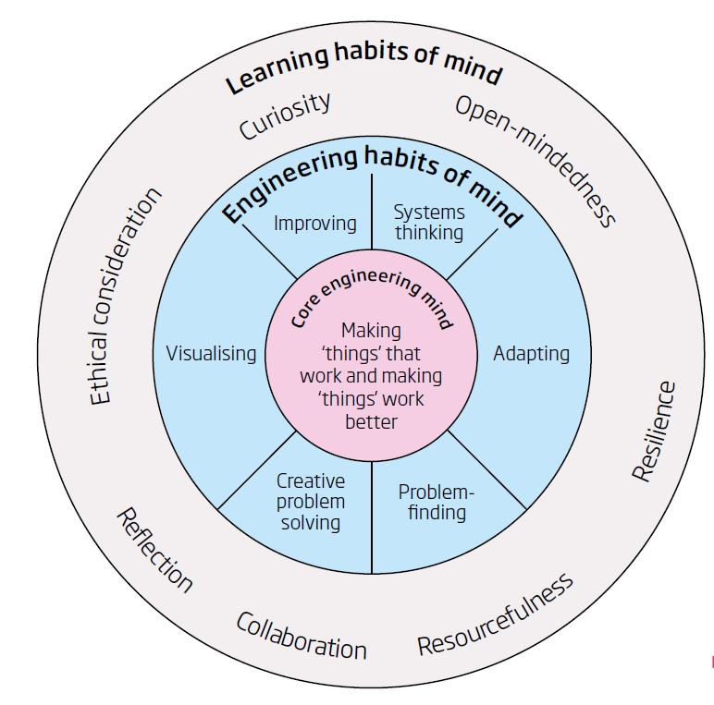

Centre for Real-World Learning’s Creative habits of mind5 6

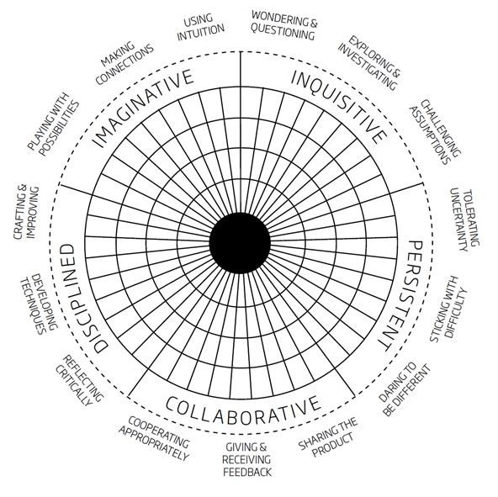

4 Lucas, B., Hanson, J., and Claxton, G. (2014) Thinking like an engineer. London: Royal Academy of Engineering. Available: www.raeng.org.uk/thinkinglikeanengineer.
5 Lucas, B, and E. Spencer (2017) Teaching Creative Thinking: Developing learners who generate ideas and can think critically.
Carmarthen: Crown Publishing
6 Lucas, B., Claxton, G. and E. Spencer (2013) ‘Progression in Student Creativity in School: First Steps Towards New Forms of Formative Assessments’, OECD Education. Working Papers, No. 86, OECD Publishing. http://dx.doi.org/10.1787/5k4dp59msdwk-en

Here are two examples of schools which have developed these ideas:

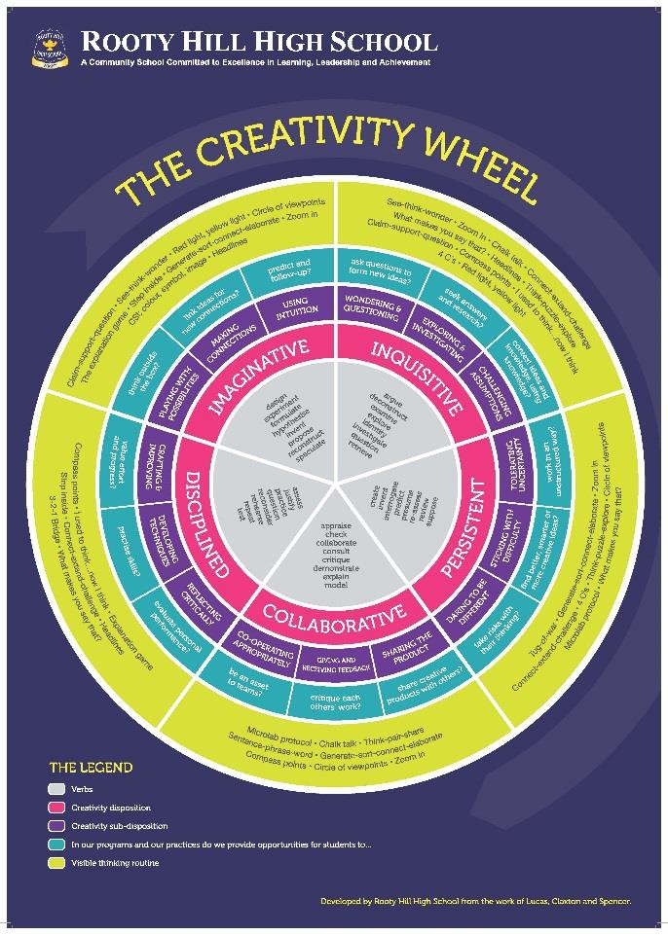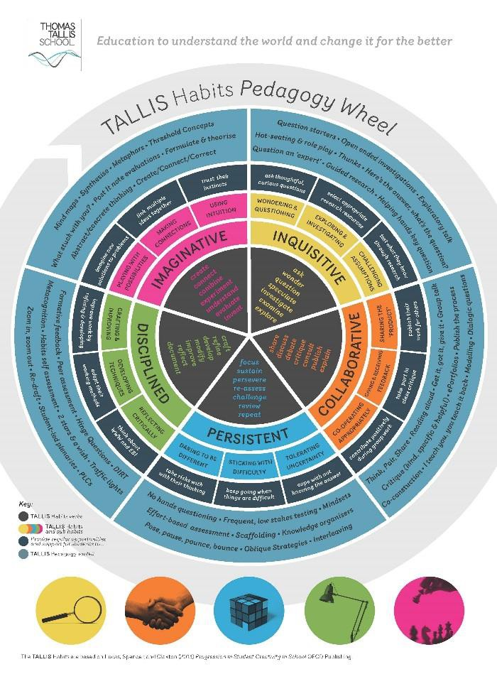
Recently CRL has developed a model of tenacity with four HofM:

Centre for Real-World Learning’s model of tenacity 7
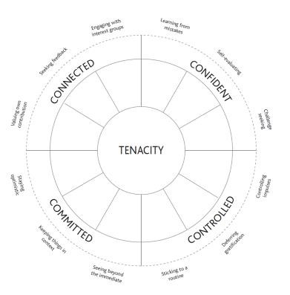

7 Lucas, B, and E. Spencer (2018) Developing Tenacity: Teaching learners how to persevere in the face of difficulty. Carmarthen: Crown Publishing

